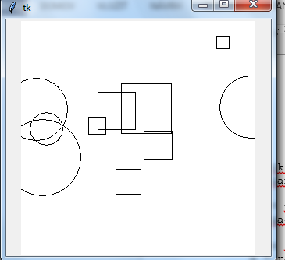
Podmienený príkaz

import tkinter
import random

canvas = tkinter.Canvas(bg='white', width=300, height=300)
canvas.pack()

for i in range(10):
x = random.randrange(300)
y = random.randrange(300)
a = random.randrange(5, 50)

if random.randrange(2): # t.j. random.randrange(2) != 0
canvas.create_oval(x-a, y-a, x+a, y+a)
else:
canvas.create_rectangle(x-a, y-a, x+a, y+a)
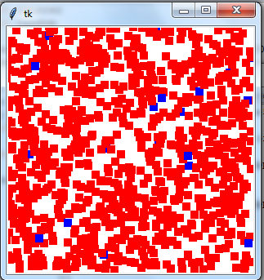

import tkinter
import random

canvas = tkinter.Canvas(bg='white', width=300, height=300)
canvas.pack()

for i in range(1000):
x = random.randrange(300)
y = random.randrange(300)
if random.randrange(50): # t.j. random.randrange(50) != 0
farba = 'red'
else:
farba = 'blue'
canvas.create_rectangle(x-5, y-5, x+5, y+5, fill=farba, outline='')

ZDROJE NA ŠTÚDIUM A CVIČENIE
https://input.sk/python2017/10.html

